CSE 581

**Lab 12: Functions**

Nidhi Surya Prakash

SUID:215895619

**Purpose:**

Create a function and execute it.

**Deliverables:**

Multiple screenshots, as described through the lab.

Scripts that you used to carry out the actions.

**Steps:**

1. Create a function that will accept CourseId and Numerical Grade and will calculate the letter grade. The function will return the appropriate *Letter Grade Description* based on the input and the ***CourseGrade & LetterGrades*** table[1][2] you created in Lab 7 & 8. Provide a **screenshot** of the function being created.

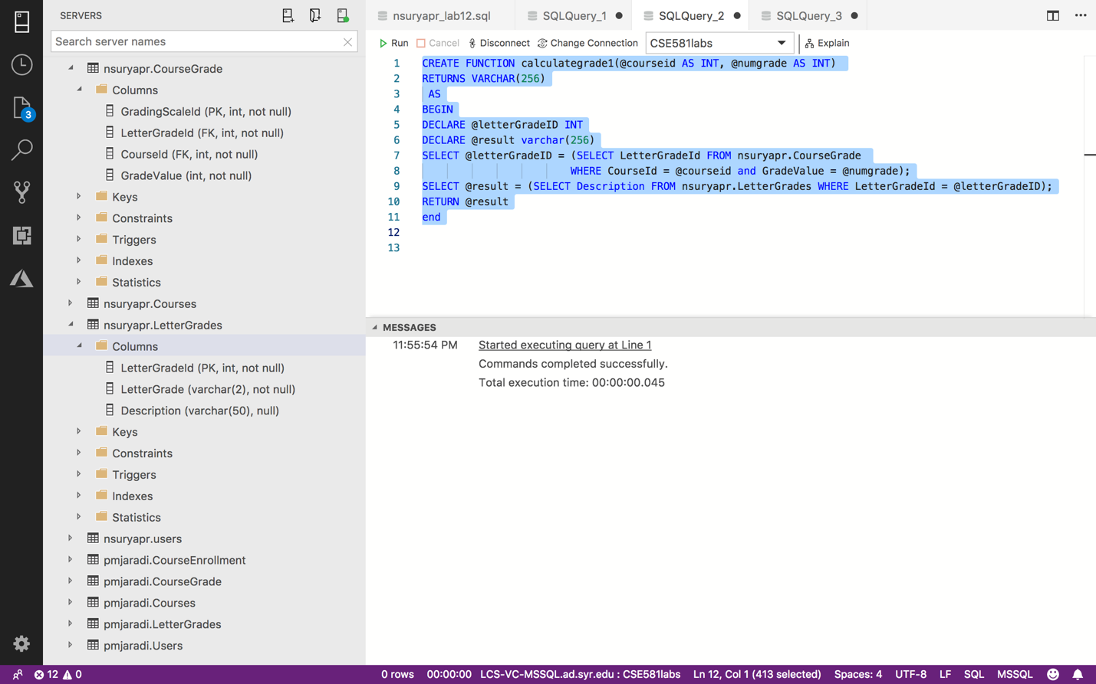

1. Take a **screenshot** of the table containing Letter Grade Description, Course Id and Numerical grade, so that way both you and I can check that the function works properly.

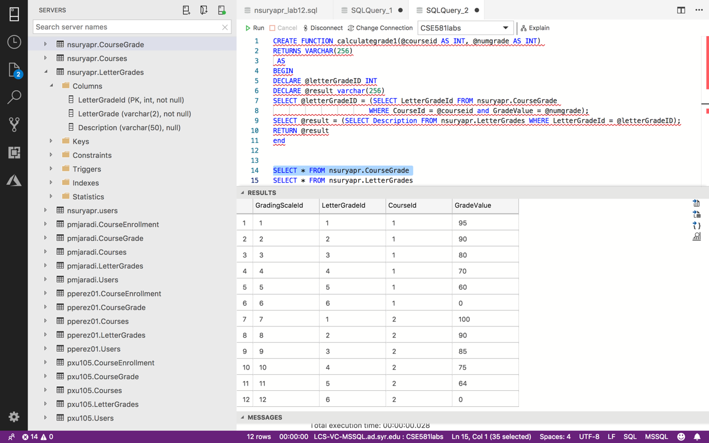

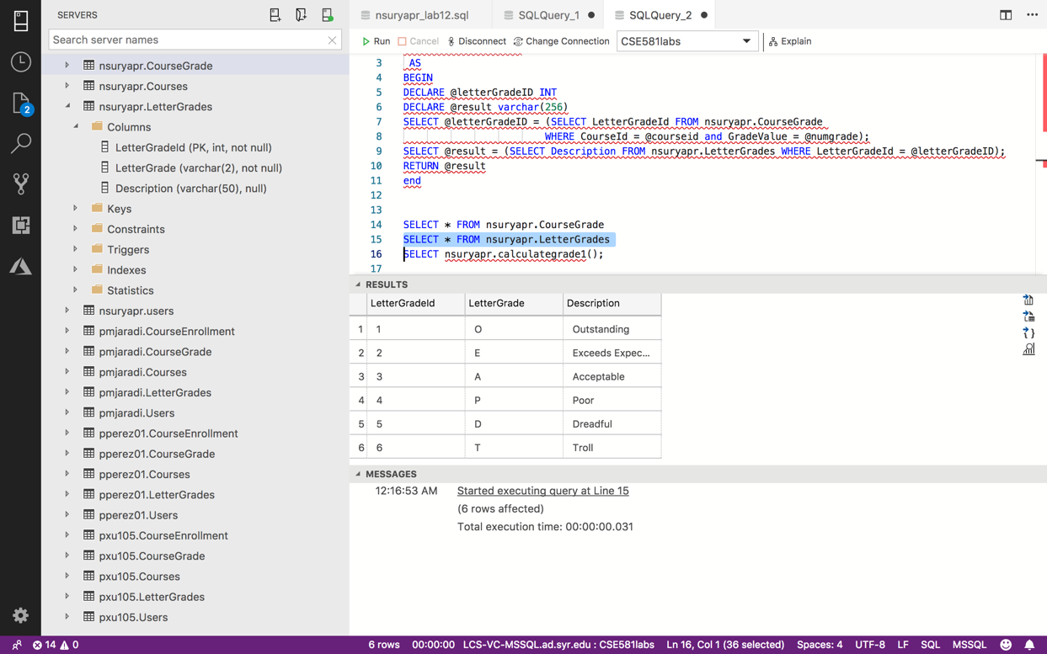

1. Run the function for the CourseId = 1, NumericalGrade = 95. Provide a **screenshot** of execution, showing the result.

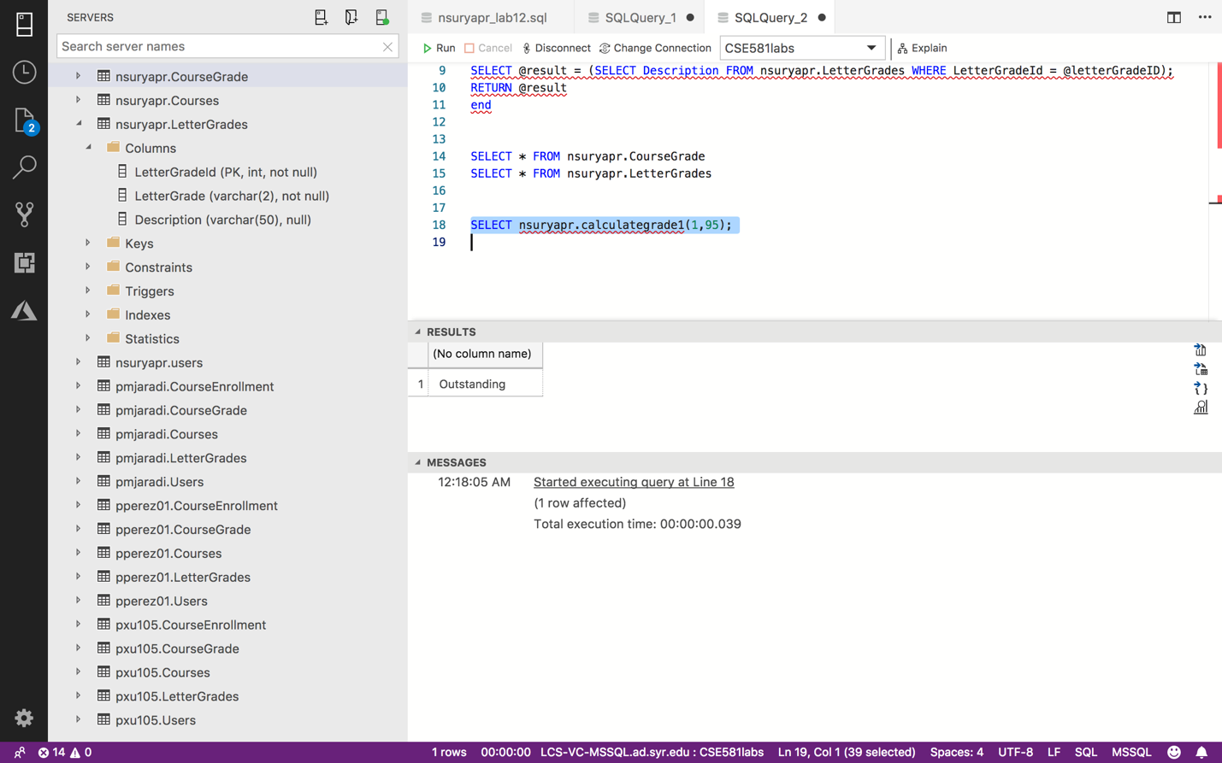

1. Run the function for the CourseId = 2, NumericalGrade = 95. Provide a **screenshot** of execution, showing the result.

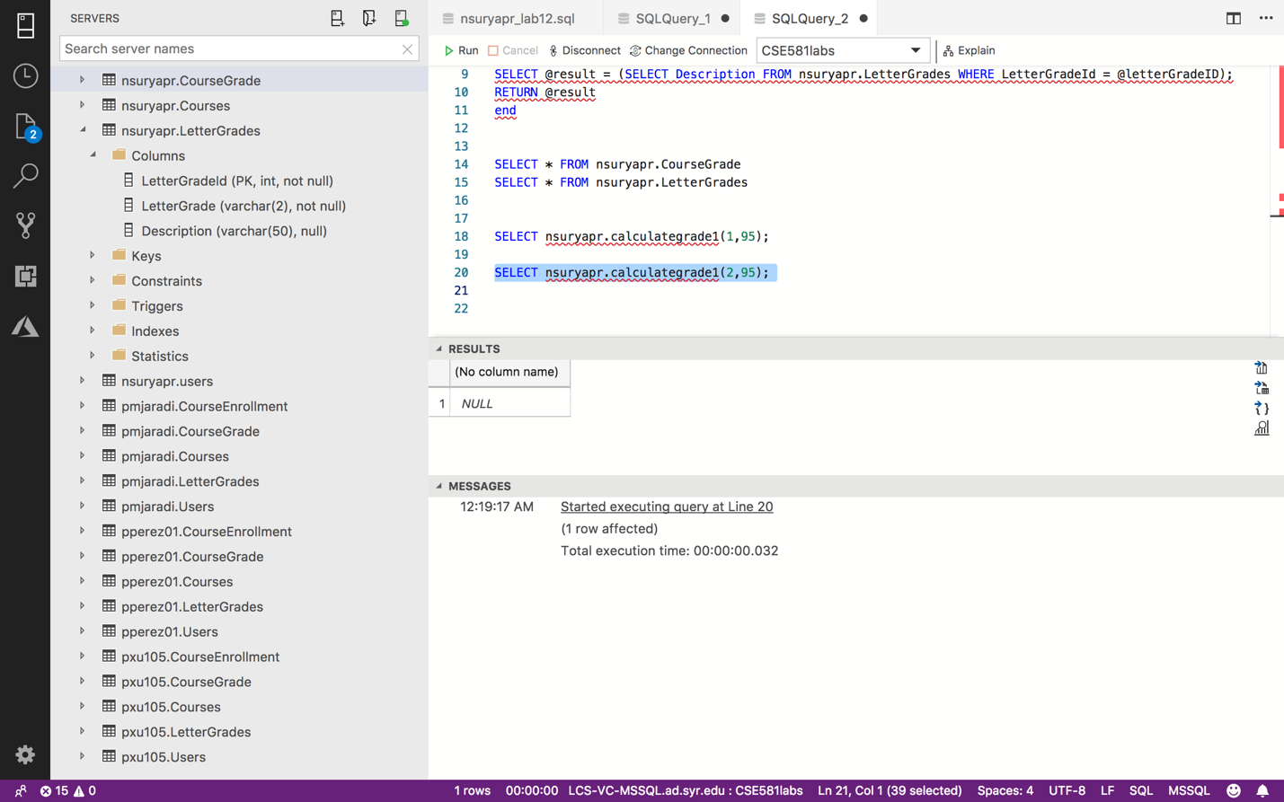

1. Run the function for the CourseId = 2, NumericalGrade = 85. Provide a **screenshot** of execution, showing the result.

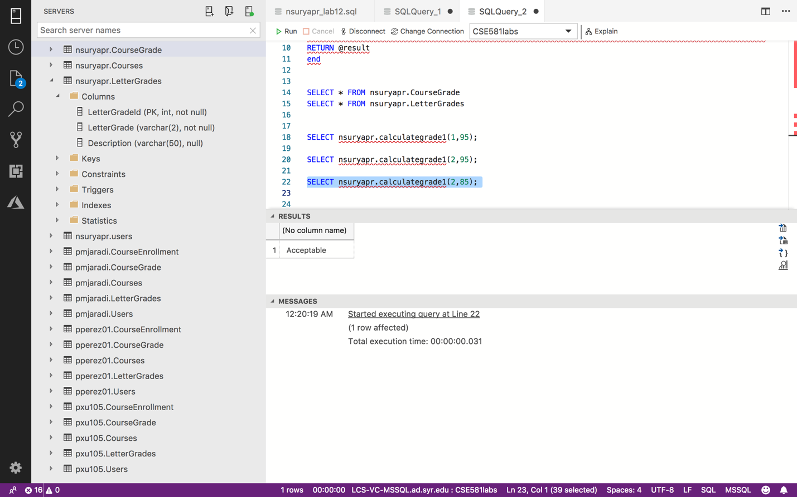

1. Please consider how grades are calculated. For example, if 90-92.9 is an A-, and you get a 92, then you get an A-.
2. Please do not hardcode values into your function. Use the table to make the decisions.